Corporate Finance, 4e (Berk / DeMarzo)
Chapter 16 Financial Distress, Managerial Incentives, and Information

16.1 Default and Bankruptcy in a Perfect Market

1) Which of the following statements is FALSE?
A) Equity holders expect to receive dividends and the firm is legally obligated to pay them.
B) A firm that fails to make the required interest or principal payments on the debt is in default.
C) In the extreme case, the debt holders take legal ownership of the firm's assets through a process called bankruptcy.
D) After a firm defaults, debt holders are given certain rights to the assets of the firm.
Answer: A
Diff: 1
Section: 16.1 Default and Bankruptcy in a Perfect Market
Skill: Conceptual

2) Which of the following statements is FALSE?
A) An important consequence of leverage is the risk of bankruptcy.
B) Whether default occurs depends on the cash flows, not on the relative values of the firm's assets and liabilities.
C) Economic distress is a significant decline in the value of a firm's assets, whether or not it experiences financial distress due to leverage.
D) Modigliani and Miller's results continue to hold in a perfect market even when debt is risky and the firm may default.
Answer: B
Diff: 2
Section: 16.1 Default and Bankruptcy in a Perfect Market
Skill: Conceptual

Use the information for the question(s) below.

Monsters Incorporated (MI) in ready to launch a new product. Depending upon the success of this product, MI will have a value of either $100 million, $150 million, or $191 million, with each outcome being equally likely. The cash flows are unrelated to the state of the economy (i.e. risk from the project is diversifiable) so that the project has a beta of 0 and a cost of capital equal to the risk-free rate, which is currently 5%. Assume that the capital markets are perfect.

3) The initial value of MI's equity without leverage is closest to:
A) $133 million
B) $147 million
C) $140 million
D) $150 million
Answer: C
Explanation: C) VU = 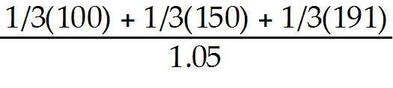 = $140 million
Diff: 1
Section: 16.1 Default and Bankruptcy in a Perfect Market
Skill: Analytical
4) Suppose that MI has zero-coupon debt with a $125 million face value due next year. The initial value of MI's debt is closest to:
A) $125 million
B) $111 million
C) $100 million
D) $116 million
Answer: B
Explanation: B) Vdebt = 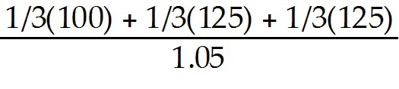 = $111.11 million
Diff: 2
Section: 16.1 Default and Bankruptcy in a Perfect Market
Skill: Analytical

5) Suppose that MI has zero-coupon debt with a $125 million face value due next year. The yield to maturity of MI's debt is closest to:
A) 12.5%
B) 7.8%
C) 25.0%
D) 5.0%
Answer: A
Explanation: A) Vdebt = = $111.11 million

YTM = 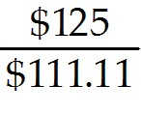 - 1 = .125011 or 12.5%
Diff: 2
Section: 16.1 Default and Bankruptcy in a Perfect Market
Skill: Analytical

6) Suppose that MI has zero-coupon debt with a $125 million face value due next year. The expected return of MI's debt is closest to:
A) 25.0%
B) 12.5%
C) 5.0%
D) 7.8%
Answer: C
Explanation: C) Vdebt = = $111.11 million

Expected Return = 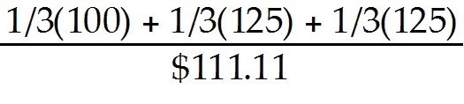 = .05 or 5%
Diff: 3
Section: 16.1 Default and Bankruptcy in a Perfect Market
Skill: Analytical
7) Suppose that MI has zero-coupon debt with a $125 million face value due next year. The initial value of MI's equity is closest to:
A) $30 million
B) $15 million
C) $29 million
D) $24 million
Answer: C
Explanation: C) VL = 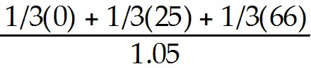 = $28.89 million
Diff: 2
Section: 16.1 Default and Bankruptcy in a Perfect Market
Skill: Analytical

8) Suppose that MI has zero-coupon debt with a $125 million face value due next year. The total value of MI with leverage is closest to:
A) $133 million
B) $140 million
C) $147 million
D) $125 million
Answer: B
Explanation: B) VL = = $28.89 million

Vdebt = = $111.11 million

Total Value = VL + Vdebt = $28.89 + $111.11 = $140 million
Diff: 2
Section: 16.1 Default and Bankruptcy in a Perfect Market
Skill: Analytical

Use the information for the question(s) below.

Kinston Enterprises has no debt and a debt obligation of $47 million that is due now. The market value of Kinston's assets is $102 million, and the firm has no other liabilities. Assume that capital markets are perfect and that Kinston has 5 million shares outstanding.

9) Kinston's current share price is closest to:
A) $20.40
B) $9.40
C) $11.00
D) $10.00
Answer: C
Explanation: C) Price = 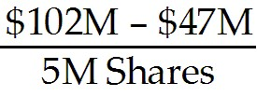 = $11.00 per share
Diff: 1
Section: 16.1 Default and Bankruptcy in a Perfect Market
Skill: Analytical
10) The number of new shares that Kinston must issue to raise the capital needed to pay its debt obligation is closest to:
A) 4.3 million
B) 4.7 million
C) 5.0 million
D) 4.0 million
Answer: A
Explanation: A) Price = = $11.00 per share

Number of Shares = 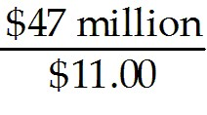 = 4,272,728 shares
Diff: 2
Section: 16.1 Default and Bankruptcy in a Perfect Market
Skill: Analytical

Use the information for the question(s) below.

Monsters Incorporated (MI) in ready to launch a new product. Depending upon the success of this product, MI will have a value of either $100 million, $150 million, or $191 million, with each outcome being equally likely. The cash flows are unrelated to the state of the economy (i.e. risk from the project is diversifiable) so that the project has a beta of 0 and a cost of capital equal to the risk-free rate, which is currently 5%. Assume that the capital markets are perfect.

11) Suppose that MI has zero-coupon debt with a $140 million face value due next year. Calculate the value of levered equity, the value of debt, and the total value of MI with leverage.
Answer: VL = 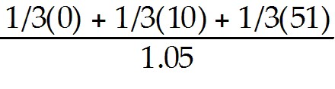 = $19.37 million

Vdebt = 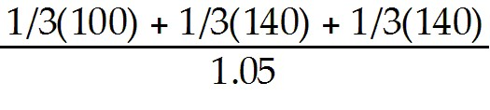 = $120.63 million

Total Value = VL + Vdebt = $19.37 + $120.63 = $140 million
Diff: 2
Section: 16.1 Default and Bankruptcy in a Perfect Market
Skill: Analytical
16.2 The Costs of Bankruptcy and Financial Distress

1) Taggart Transcontinental has a value of $500 million if it continues to operate, but has outstanding debt of $600 million. If Taggart declares bankruptcy, bankruptcy costs will equal $50 million, and the remaining $450 million will go to creditors. Instead of declaring bankruptcy, Taggart proposes to exchange the firm's debt for a fraction of its equity in a workout. The minimum fraction of the firm's equity that Taggart would need to offer to its creditors for the workout to be successful is closest to:
A) 50%
B) 75%
C) 83%
D) 90%
Answer: D
Explanation: D) Debt holders will need to be at least as well off as if the firm went into liquidation. In liquidation the debt holders would receive $450 million, however if the firm continues to operate it will have a value of $500 million. Therefore, $450 million = percent ownership for debt holders × $500 total value.
Solving for percent ownership gives $450/$500 = 90%
Diff: 1
Section: 16.2 The Costs of Bankruptcy and Financial Distress
Skill: Analytical

Use the following information to answer the question(s) below.

Suppose that you have received two job offers. Rearden Metal offers you a contract for $75,000 per year for the next two years while Wyatt Oil offers you a contract for $90,000 per year for the next two years. Both jobs are equivalent. Suppose that Rearden Metal's contract is certain, but Wyatt Oil has a 60% chance of going bankrupt at the end of the year. In the event that Wyatt Oil files for bankruptcy, it will cancel your contract and pay you the lowest amount possible for you to not quit. If you do quit, you expect you could find an new job paying $75,000 per year, but you would be unemployed for four months while searching for this new job.

2) If you take the job with Wyatt Oil, then, in the event of bankruptcy, the least amount that Wyatt Oil would pay you next year is closest to:
A) $45,000
B) $50,000
C) $54,000
D) $75,000
Answer: B
Explanation: B) If you quit, you will be out of work for 4 months searching for a job leaving 8 months of employment at $75,000 per year or 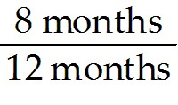 × $75,000 = $50,000
Diff: 1
Section: 16.2 The Costs of Bankruptcy and Financial Distress
Skill: Analytical
3) Assuming your cost of capital is 6 percent, the present value of your expected wage if you accept Rearden Metal's offer is closest to:
A) $133,000
B) $138,000
C) $140,000
D) $144,000
Answer: B
Explanation: B) PVRearden = 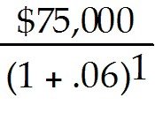 + 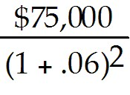 = $137,504.45
Diff: 2
Section: 16.2 The Costs of Bankruptcy and Financial Distress
Skill: Analytical

4) Assuming your cost of capital is 6 percent, the present value of your expected wage if you accept Wyatt Oil's offer is closest to:
A) $138,000
B) $140,000
C) $144,000
D) $150,000
Answer: C
Explanation: C) If you quit, you will be out of work for 4 months searching for a job leaving 8 months of employment at $75,000 per year or × $75,000 = $50,000
PVWyatt = 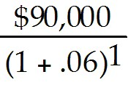 + 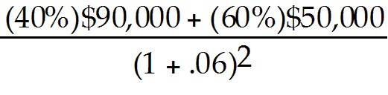 = $143,645.43
Diff: 2
Section: 16.2 The Costs of Bankruptcy and Financial Distress
Skill: Analytical
5) Assuming your cost of capital is 6 percent, based on the present value of your expected wage you should:
A) accept Rearden's offer since the PV of your expected wage would be approximately $6000 higher.
B) accept Rearden's offer since the PV of your expected wage would be approximately $8000 lower.
C) accept Rearden's offer since the PV of your expected wage would be approximately $8000 higher.
D) accept Wyatt's offer since the PV of your expected wage would be approximately $6000 higher.
Answer: D
Explanation: D) If you quit, you will be out of work for 4 months searching for a job leaving 8 months of employment at $75,000 per year or × $75,000 = $50,000
PVWyatt = + = $143,645.43
PVRearden = + = $137,504.45
Difference = 143,645.43 - 137,504.45 = $6140.98 ← Amount better off by accepting Wyatt's offer.
Diff: 3
Section: 16.2 The Costs of Bankruptcy and Financial Distress
Skill: Analytical

6) Which of the following statements is FALSE?
A) When a firm fails to make a required payment to debt holders, it is in bankruptcy.
B) With perfect capital markets, the risk of bankruptcy is not a disadvantage of debt—bankruptcy simply shifts the ownership of the firm from equity holders to debt holders without changing the total value available to all investors.
C) Bankruptcy is a long and complicated process that imposes both direct and indirect costs on the firm and its investors that the assumption of perfect capital markets ignores.
D) Bankruptcy is rarely simple and straightforward—equity holders don't just "hand the keys" to debt holders the moment the firm defaults on a debt payment.
Answer: A
Diff: 1
Section: 16.2 The Costs of Bankruptcy and Financial Distress
Skill: Conceptual
7) Which of the following statements is FALSE?
A) The U.S. bankruptcy code was created to organize this process so that creditors are treated fairly and the value of the assets is not needlessly destroyed.
B) Because the assets of the firm might be more valuable if kept together, creditors seizing assets in a piecemeal fashion might destroy much of the remaining value of the firm.
C) Debt holders can then take legal action against the firm to collect payment by seizing the firm's assets.
D) Because most firms have multiple creditors, coordination makes it difficult to guarantee that each creditor will be treated fairly.
Answer: D
Diff: 1
Section: 16.2 The Costs of Bankruptcy and Financial Distress
Skill: Conceptual

8) Which of the following statements is FALSE?
A) According to the provisions of the 1978 Bankruptcy Reform Act, U.S. firms can file for two forms of bankruptcy protection: Chapter 11 or Chapter 13.
B) The Chapter 11 reorganization plan specifies the treatment of each creditor of the firm. In addition to cash payment, creditors may receive new debt or equity securities of the firm. The value of cash and securities is generally less than the amount each creditor is owed, but more than the creditors would receive if the firm were shut down immediately and liquidated.
C) In the more common form of bankruptcy for large corporations, Chapter 11 reorganization, all pending collection attempts are automatically suspended, and the firm's existing management is given the opportunity to propose a reorganization plan.
D) While developing a Chapter 11 reorganization plan, management continues to operate the business.
Answer: A
Diff: 2
Section: 16.2 The Costs of Bankruptcy and Financial Distress
Skill: Conceptual

9) Which of the following statements is FALSE?
A) The creditors must vote to accept the Chapter 11 reorganization plan, and the bankruptcy court must approve it. If an acceptable plan is not put forth, the court may ultimately force a Chapter 7 liquidation of the firm.
B) In Chapter 13 liquidation, a trustee is appointed to oversee the liquidation of the firm's assets through an auction. The proceeds from the liquidation are used to pay the firm's creditors, and the firm ceases to exist.
C) When a corporation becomes financially distressed, outside professionals, such as legal and accounting experts, consultants, appraisers, auctioneers, and others with experience selling distressed assets, are generally hired.
D) In the case of Chapter 11 reorganization, creditors must often wait several years for a reorganization plan to be approved and to receive payment.
Answer: B
Diff: 2
Section: 16.2 The Costs of Bankruptcy and Financial Distress
Skill: Conceptual
10) Which of the following statements is FALSE?
A) Whether paid by the firm or its creditors, the indirect costs of bankruptcy increase the value of the assets that the firm's investors will ultimately receive.
B) In addition to the money spent by the firm, the creditors may incur costs during the bankruptcy process.
C) The bankruptcy code is designed to provide an orderly process for settling a firm's debts.
D) To ensure that their rights and interests are respected, and to assist in valuing their claims in a proposed reorganization, creditors may seek separate legal representation and professional advice.
Answer: A
Diff: 2
Section: 16.2 The Costs of Bankruptcy and Financial Distress
Skill: Conceptual

11) Which of the following statements is FALSE?
A) The direct costs of bankruptcy are likely to be higher for firms with more complicated business operations and for firms with larger numbers of creditors, because it may be more difficult to reach agreement among many creditors regarding the final disposition of the firm's assets.
B) In a prepackaged bankruptcy (or "prepack") a firm will first develop a reorganization plan with the agreement of its main creditors, and then file Chapter 7 to implement the plan and pressure any creditors who attempt to hold out for better terms.
C) A study of Chapter 7 liquidations of small businesses found that the average direct costs of bankruptcy were 12% of the value of the firm's assets.
D) Studies typically report that the average direct costs of bankruptcy are approximately 3% to 4% of the pre-bankruptcy market value of total assets.
Answer: B
Diff: 2
Section: 16.2 The Costs of Bankruptcy and Financial Distress
Skill: Conceptual

12) Which of the following statements is FALSE?
A) Although indirect costs of bankruptcy are difficult to measure accurately, they are typically much smaller than the direct costs of bankruptcy.
B) Bankruptcy protection can be used by management to delay the liquidation of a firm that should be shut down.
C) Because many aspects of the bankruptcy process are independent of the size of the firm, the costs are typically higher, in percentage terms, for smaller firms.
D) Aside from the direct legal and administrative costs of bankruptcy, many other indirect costs are associated with financial distress (whether or not the firm has formally filed for bankruptcy).
Answer: A
Diff: 2
Section: 16.2 The Costs of Bankruptcy and Financial Distress
Skill: Conceptual
13) Which of the following statements is FALSE?
A) The costs of selling assets below their value are greatest for firms with assets that lack competitive, liquid markets.
B) Firms in financial distress tend to have difficulty collecting money that is owed to them.
C) Suppliers may be unwilling to provide a firm with inventory if they fear they will not be paid.
D) The loss of customers is likely to be large for producers of raw materials (such as sugar or aluminum), as the value of these goods, once delivered, depends on the seller's continued success.
Answer: D
Diff: 2
Section: 16.2 The Costs of Bankruptcy and Financial Distress
Skill: Conceptual

14) Which of the following is NOT an indirect cost of bankruptcy?
A) Legal fees
B) Delayed liquidation
C) Costs to creditors
D) Loss of customers
Answer: A
Diff: 1
Section: 16.2 The Costs of Bankruptcy and Financial Distress
Skill: Conceptual

15) Which of the following is NOT an indirect cost of bankruptcy?
A) Loss of suppliers
B) Fire sales of assets
C) Costs of appraisers
D) Loss of employees
Answer: C
Diff: 1
Section: 16.2 The Costs of Bankruptcy and Financial Distress
Skill: Conceptual

16) Which of the following is NOT a direct cost of bankruptcy?
A) Costs to creditors
B) Investment banking costs
C) Costs of accounting experts
D) Legal costs and fees
Answer: A
Diff: 1
Section: 16.2 The Costs of Bankruptcy and Financial Distress
Skill: Conceptual
17) Because debtor-in-possession (DIP) financing is senior to all existing creditors:
A) it allows a firm that has filed for bankruptcy renewed access to financing to keep operating.
B) it is an important cost for firms that rely heavily on trade credit.
C) it is likely to be small for producers of raw materials, as the value of those goods, once delivered, does not depend on the seller's continued success.
D) it allows debtors to assume they may have an opportunity to avoid their obligations to a firm.
Answer: A
Diff: 1
Section: 16.2 The Costs of Bankruptcy and Financial Distress
Skill: Definition

18) List five general categories of indirect costs associated with bankruptcy.
Answer: Indirect Costs:
Costs to Creditors
Loss of Customers
Loss of Suppliers
Loss of Employees
Loss of Receivables
Fire Sales of Assets
Delayed Liquidation
Diff: 1
Section: 16.2 The Costs of Bankruptcy and Financial Distress
Skill: Conceptual

16.3 Financial Distress Costs and Firm Value

1) Which of the following statements is FALSE?
A) Debt holders are not foolish—they recognize that when the firm defaults, they will not be able to get the full value of the assets. As a result, they will pay less for the debt initially.
B) The costs of financial distress represent an important departure from Modigliani and Miller's assumption of perfect capital markets.
C) Levered firms risk incurring financial distress costs that reduce the cash flows available to investors.
D) When securities are fairly priced, the original shareholders of a firm pay the future value of the costs associated with bankruptcy and financial distress.
Answer: D
Diff: 1
Section: 16.3 Financial Distress Costs and Firm Value
Skill: Conceptual
Use the information for the question(s) below.

Monsters Incorporated (MI) in ready to launch a new product. Depending upon the success of this product, MI will have a value of either $100 million, $150 million, or $191 million, with each outcome being equally likely. The cash flows are unrelated to the state of the economy (i.e. risk from the project is diversifiable) so that the project has a beta of 0 and a cost of capital equal to the risk-free rate, which is currently 5%. Assume that the capital markets are perfect.

2) Assuming that in the event of default, 20% of the value of MI's assets will be lost in bankruptcy costs, the initial value of MI's equity without leverage is closest to:
A) $150 million
B) $147 million
C) $140 million
D) $133 million
Answer: C
Explanation: C) VU = = $140 million
Diff: 1
Section: 16.3 Financial Distress Costs and Firm Value
Skill: Analytical

3) Assume that in the event of default, 20% of the value of MI's assets will be lost in bankruptcy costs and suppose that MI has zero-coupon debt with a $125 million face value due next year. The initial value of MI's debt is closest to:
A) $110 million
B) $105 million
C) $125 million
D) $111 million
Answer: B
Explanation: B) Vdebt = 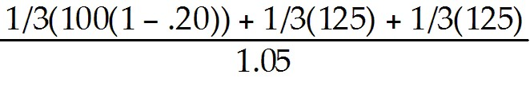 = $104.76 million
Diff: 2
Section: 16.3 Financial Distress Costs and Firm Value
Skill: Analytical

4) Assume that in the event of default, 20% of the value of MI's assets will be lost in bankruptcy costs and suppose that MI has zero-coupon debt with a $125 million face value due next year. The yield to maturity of MI's debt is closest to:
A) 13.75%
B) 5.00%
C) 19.25%
D) 12.50%
Answer: C
Explanation: C) Vdebt = = $104.76 million
YTM = 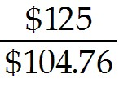 - 1 = .193182 or 19.3%
Diff: 2
Section: 16.3 Financial Distress Costs and Firm Value
Skill: Analytical
5) Assume that in the event of default, 20% of the value of MI's assets will be lost in bankruptcy costs and suppose that MI has zero-coupon debt with a $125 million face value due next year. The initial value of MI's equity is closest to:
A) $30 million
B) $29 million
C) $15 million
D) $24 million
Answer: B
Explanation: B) VL = = $28.89 million
Diff: 2
Section: 16.3 Financial Distress Costs and Firm Value
Skill: Analytical

6) Assume that in the event of default, 20% of the value of MI's assets will be lost in bankruptcy costs and suppose that MI has zero-coupon debt with a $125 million face value due next year. The total value of MI with leverage is closest to:
A) $140 million
B) $100 million
C) $125 million
D) $134 million
Answer: D
Explanation: D) VL = = $28.89 million

Vdebt = = $104.76 million

Total Value = VL + Vdebt = $28.89 + $104.76 = $133.65 million
Diff: 2
Section: 16.3 Financial Distress Costs and Firm Value
Skill: Analytical

7) Assume that in the event of default, 20% of the value of MI's assets will be lost in bankruptcy costs and suppose that MI has zero-coupon debt with a $125 million face value due next year. The present value of MI's financial distress costs is closest to:
A) $20.0 million
B) $6.6 million
C) $6.3 million
D) $19.0 million
Answer: C
Explanation: C) PV(Financial Distress Costs) = 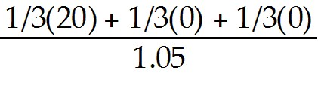 = $6.349 million
Diff: 2
Section: 16.3 Financial Distress Costs and Firm Value
Skill: Analytical
8) Assume that in the event of default, 20% of the value of MI's assets will be lost in bankruptcy costs. Suppose that at the start of the year, MI has no debt outstanding, but has 5.6 million shares of stock outstanding. If MI does not issue debt, its share price is closest to:
A) $5.15
B) $23.75
C) $23.90
D) $25.00
Answer: D
Explanation: D) VU = = $140 million

Price per Share = $140M/5.6 million shares = $25.00
Diff: 1
Section: 16.3 Financial Distress Costs and Firm Value
Skill: Analytical

9) Assume that in the event of default, 20% of the value of MI's assets will be lost in bankruptcy costs. Suppose that at the start of the year, MI has no debt outstanding, but has 5.6 million shares of stock outstanding. If MI issues debt of $125 million due next year and uses the proceeds to repurchase shares, the share price following the announcement of the repurchase will be closest to:
A) $23.90
B) $23.75
C) $25.00
D) $5.15
Answer: A
Explanation: A) VL = = $28.89 million

Vdebt = = $104.76 million

Total Value = VL + Vdebt = $28.89 + $104.76 = $133.65 million

Price per Share = $133.65M/5.6 million shares = $23.87
Diff: 3
Section: 16.3 Financial Distress Costs and Firm Value
Skill: Analytical
10) Assume that in the event of default, 20% of the value of MI's assets will be lost in bankruptcy costs and suppose that MI has zero-coupon debt with a $140 million face value due next year. Calculate the value of levered equity, the value of debt, and the total value of MI with leverage.
Answer: VL = = $19.37 million

Vdebt = 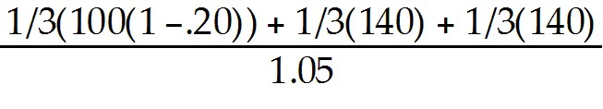 = $114.29 million

Total Value = VL + Vdebt = $19.37 + $114.29 = $133.66 million
Diff: 3
Section: 16.3 Financial Distress Costs and Firm Value
Skill: Analytical

16.4 Optimal Capital Structure: The Trade-off Theory

Use the following information to answer the question(s) below.

d'Anconia Copper is considering issuing one year debt, and has come up with the following estimates of the value of the interest tax shield and the probability of distress for different levels of debt:

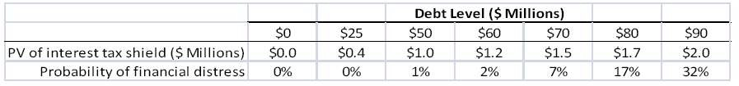

1) If in the event of distress, the present value of distress costs is equal to $10 million, then the optimal level of debt for d'Anconia Copper is:
A) $25 million
B) $50 million
C) $60 million
D) $70 million
Answer: C
Explanation: C) Select $60 million since it has the highest net benefit.
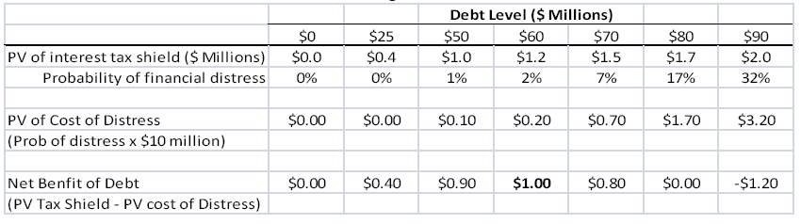
Diff: 2
Section: 16.4 Optimal Capital Structure: The Tradeoff Theory
Skill: Analytical
2) If in the event of distress, the present value of distress costs is equal to $5 million, then the optimal level of debt for d'Anconia Copper is:
A) $25 million
B) $50 million
C) $60 million
D) $70 million
Answer: D
Explanation: D) Select $70 million since it has the highest net benefit.
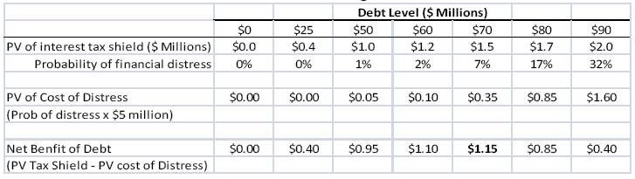
Diff: 2
Section: 16.4 Optimal Capital Structure: The Tradeoff Theory
Skill: Analytical

3) If in the event of distress, the present value of distress costs is equal to $25 million, then the optimal level of debt for d'Anconia Copper is:
A) $50 million
B) $60 million
C) $70 million
D) $80 million
Answer: A
Explanation: A) Select $50 million since it has the highest net benefit.
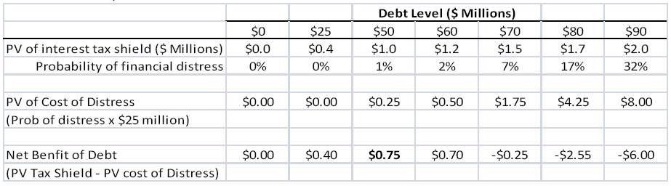
Diff: 2
Section: 16.4 Optimal Capital Structure: The Tradeoff Theory
Skill: Analytical
4) Which of the following statements is FALSE?
A) The tradeoff theory weighs the costs of debt that result from shielding cash flows from taxes against the benefits from the effects of financial distress associated with leverage.
B) Leverage has costs as well as benefits.
C) According to the tradeoff theory, the total value of a levered firm equals the value of the firm without leverage plus the present value of the tax savings from debt, less the present value of financial distress costs.
D) Firms have an incentive to increase leverage to exploit the tax benefits of debt. But with too much debt, they are more likely to risk default and incur financial distress costs.
Answer: A
Diff: 1
Section: 16.4 Optimal Capital Structure: The Tradeoff Theory
Skill: Conceptual

5) Which of the following statements is FALSE?
A) Calculating the precise present value of financial distress costs is a relatively straightforward process.
B) Two key qualitative factors determine the present value of financial distress costs: (1) the probability of financial distress and (2) the magnitude of the costs after a firm is in distress.
C) Technology firms are likely to incur high costs when they are in financial distress, due to the potential for loss of customers and key personnel, as well as a lack of tangible assets that can be easily liquidated.
D) The magnitude of the financial distress costs will depend on the relative importance of the sources of these costs and is likely to vary by industry.
Answer: A
Diff: 1
Section: 16.4 Optimal Capital Structure: The Tradeoff Theory
Skill: Conceptual

6) Which of the following statements is FALSE?
A) Real estate firms are likely to have low costs of financial distress, as much of their value derives from assets that can be sold relatively easily.
B) For low levels of debt, the risk of default remains low and the main effect of an increase in leverage is an increase in the interest tax shield, which has present value τ*D, where τ* is the effective tax advantage of debt.
C) Firms whose value and cash flows are very volatile (for example, semiconductor firms) must have much higher levels of debt to avoid a significant risk of default.
D) The probability of financial distress depends on the likelihood that a firm will be unable to meet its debt commitments and therefore default.
Answer: C
Diff: 2
Section: 16.4 Optimal Capital Structure: The Tradeoff Theory
Skill: Conceptual
7) Which of the following statements is FALSE?
A) Firms with steady, reliable cash flows, such as utility companies, are able to use high levels of debt and still have a very low probability of default.
B) If there were no costs of financial distress, the value of the firm would continue to increase with increasing debt until the interest on the debt exceeds the firm's earnings before interest and taxes and the tax shield is exhausted.
C) The costs of financial distress reduce the value of the levered firm, VL. The amount of the reduction decreases with the probability of default, which in turn increases with the level of the debt D.
D) The tradeoff theory states that firms should increase their leverage until it reaches the level D* for which VL is maximized.
Answer: C
Diff: 2
Section: 16.4 Optimal Capital Structure: The Tradeoff Theory
Skill: Conceptual

8) Which of the following statements is FALSE?
A) The presence of financial distress costs can explain why firms choose debt levels that are too high to fully exploit the interest tax shield.
B) With higher costs of financial distress, it is optimal for the firm to choose lower leverage.
C) Differences in the magnitude of financial distress costs and the volatility of cash flows can explain the differences in the use of leverage across industries.
D) At the point D*, where VL is maximized, the tax savings that result from increasing leverage are just offset by the increased probability of incurring the costs of financial distress.
Answer: A
Diff: 2
Section: 16.4 Optimal Capital Structure: The Tradeoff Theory
Skill: Conceptual

9) Which of the following industries is likely to have the lowest costs of financial distress?
A) Airlines
B) Computer software
C) Biotechnology
D) Electric utilities
Answer: D
Diff: 1
Section: 16.4 Optimal Capital Structure: The Tradeoff Theory
Skill: Conceptual

10) Which of the following industries likely to have the highest costs of financial distress?
A) Grocery store
B) Semiconductors
C) Real estate
D) Utilities
Answer: B
Diff: 1
Section: 16.4 Optimal Capital Structure: The Tradeoff Theory
Skill: Conceptual
Use the information for the question(s) below.

Big Blue Banana (BBB) is a clothing retailer with a current share price of $10.00 and with 25 million shares outstanding. Suppose that Big Blue Banana announces plans to lower its corporate taxes by borrowing $100 million and using the proceeds to repurchase shares.

11) Assuming perfect capital markets, the share price for BBB after this announcement is closest to:
A) $11.40
B) $10.85
C) $10.00
D) $8.60
Answer: C
Explanation: C) In perfect capital markets, VL = VU so even with the announcement of the increase in leverage the stock price won't change.
Diff: 1
Section: 16.4 Optimal Capital Structure: The Tradeoff Theory
Skill: Analytical

12) Suppose that BBB pays corporate taxes of 35% and that shareholders expects the change in debt to be permanent. Assuming that capital markets are perfect except for the existence of corporate taxes, the share price for BBB after this announcement is closest to:
A) $10.00
B) $10.85
C) $8.60
D) $11.40
Answer: D
Explanation: D) VU = $10.00 × 25 million shares = $250 million
VL = VU + τcB = $250 + .35($100) = $285 million/25 million shares = $11.40
Diff: 2
Section: 16.4 Optimal Capital Structure: The Tradeoff Theory
Skill: Analytical

13) Suppose that BBB pays corporate taxes of 35% and that shareholders expects the change in debt to be permanent. Assume that capital markets are perfect except for the existence of corporate taxes and financial distress costs. If the price of BBB's stock rises to $10.85 per share following the announcement, then the present value of BBB's financial distress costs is closest to:
A) $21.25 million
B) $35.00 million
C) $11.40 million
D) $13.75 million
Answer: D
Explanation: D) VU = $10.00 × 25 million shares = $250 million
VL = VU + τcB = $250 + .35($100) = $285 million/25 million shares = $11.40
PV of financial distress costs = ($11.40 - $10.85) × 25 million shares = $13.75 million
Diff: 2
Section: 16.4 Optimal Capital Structure: The Tradeoff Theory
Skill: Analytical
Use the information for the question(s) below.

Luther Industries has no debt and expects to generate free cash flows of $48 million each year. Luther believes that if it permanently increases its level of debt to $100 million, the risk of financial distress may cause it to lose some customers and receive less favorable terms from its suppliers. As a result, Luther's expected free cash flows with debt will be only $44 million per year. Suppose Luther's tax rate is 40%, the risk-free rate is 6%, the expected return of the market is 14%, and the beta of Luther's free cash flows is 1.25 (with or without leverage).

14) The value of Luther without leverage is closest to:
A) $315 million
B) $300 million
C) $205 million
D) $340 million
Answer: B
Explanation: B) RE = rf + β(rM - rf) = .06 + 1.25(.14 - .06) = .16
VU = 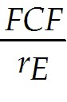 = 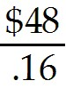 = $300 million
Diff: 2
Section: 16.4 Optimal Capital Structure: The Tradeoff Theory
Skill: Analytical

15) The value of Luther with leverage is closest to:
A) $315 million
B) $340 million
C) $205 million
D) $300 million
Answer: A
Explanation: A) RE = rf - β(rM - rf) = .06 + 1.25(.14 - .06) = .16
VU = = 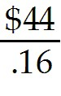 = $275 million (using lower cash flow from leverage)
VL = VU + τcD = $275 + .4($100) = $315
Diff: 2
Section: 16.4 Optimal Capital Structure: The Tradeoff Theory
Skill: Analytical
Use the information for the question(s) below.

Big Blue Banana (BBB) is a clothing retailer with a current share price of $10.00 and with 25 million shares outstanding. Suppose that Big Blue Banana announces plans to lower its corporate taxes by borrowing $100 million and using the proceeds to repurchase shares.

16) Suppose that BBB pays corporate taxes of 40% and that shareholders expects the change in debt to be permanent. Assume that capital markets are perfect except for the existence of corporate taxes and financial distress costs. If the price of BBB's stock rises to $10.80 per share following the announcement, then the present value of BBB's financial distress costs is closest to:
Answer: VU = $10.00 × 25 million shares = $250 million
VL = VU + τcB = $250 + .40($100) = $290 million/25 million shares = $11.60

PV of financial distress costs = ($11.60 - $10.80) × 25 million shares = $20 million
Diff: 2
Section: 16.4 Optimal Capital Structure: The Tradeoff Theory
Skill: Analytical

16.5 Exploiting Debt Holders: The Agency Costs of Leverage

Use the following information to answer the question(s) below.

Nielson Motors has a debt-equity ratio of 1.8, an equity beta of 1.6, and a debt beta of 0.20. It is currently evaluating the following projects, none of which would change Nielson's volatility.

Project | 1 | 2 | 3 | 4 | 5
Investment | 100 | 75 | 120 | 60 | 80
NPV | 23 | 12 | 18 | 15 | 14
(All amounts are in $millions.)

1) Nielson Motors should accept those projects with profitability ratios greater than:
A) 0.15
B) 0.175
C) 0.20
D) 0.225
Answer: D
Explanation: D) Equity holders will benefit from the new investment only when:
PI > 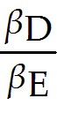 × 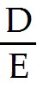 = 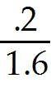 × 1.8 = 0.125 × 1.8 = .225
Diff: 2
Section: 16.5 Exploiting Debt Holders: The Agency Costs of Leverage
Skill: Analytical
2) Which of the following projects should Nielson Motors accept?
A) 1 only
B) 1, 2, and 3 only
C) 1 and 4 only
D) 2, 3, and 5 only
Answer: C
Explanation: C) Equity holders will benefit from the new investment only when:
PI > × = × 1.8 = 0.125 × 1.8 = .225
Project | 1 | 2 | 3 | 4 | 5
Investment | 100 | 75 | 120 | 60 | 80
NPV | 23 | 12 | 18 | 15 | 14
PI(NPV/Invest) | 0.23 | 0.16 | 0.15 | 0.25 | 0.175

Given the PIs above, only projects 1 and 4 are greater than .225.
Diff: 3
Section: 16.5 Exploiting Debt Holders: The Agency Costs of Leverage
Skill: Analytical

3) The total debt overhang associated with accepting project 1, is closest to:
A) $0 million
B) $12.5 million
C) $14.4 million
D) $22.5 million
Answer: D
Explanation: D) Equity holders will benefit from the new investment only when:
PI > × = × 1.8 = 0.125 × 1.8 = .225
since PI = 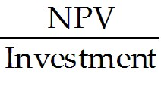, then .225 = 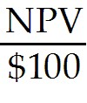 → NPV = 22.5 million total debt overhang
Diff: 2
Section: 16.5 Exploiting Debt Holders: The Agency Costs of Leverage
Skill: Analytical
4) The total debt overhang associated with accepting project 4, is closest to:
A) $0 million
B) $13.5 million
C) $15.0 million
D) $38.6 million
Answer: B
Explanation: B) Equity holders will benefit from the new investment only when:
PI > × = × 1.8 = 0.125 × 1.8 = .225
since PI = , then .225 = 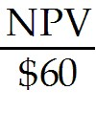 → NPV = 13.5 million total debt overhang
Diff: 2
Section: 16.5 Exploiting Debt Holders: The Agency Costs of Leverage
Skill: Analytical

5) In order for Nielson Motor's to be willing to invest, project 5 must have an NPV greater than:
A) $10.0 million
B) $12.5 million
C) $18.0 million
D) $22.5 million
Answer: C
Explanation: C) Equity holders will benefit from the new investment only when:
PI > × = × 1.8 = 0.125 × 1.8 = .225
since PI = , then .225 = 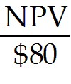 → NPV = 18.0 million
Diff: 2
Section: 16.5 Exploiting Debt Holders: The Agency Costs of Leverage
Skill: Analytical

6) In order for Nielson Motor's to be willing to invest, project 3 must have an NPV greater than:
A) $12.5 million
B) $15.0 million
C) $22.5 million
D) $27.0 million
Answer: D
Explanation: D) Equity holders will benefit from the new investment only when:
PI > × = × 1.8 = 0.125 × 1.8 = .225
since PI = , then .225 = 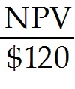 → NPV = 27.0 million
Diff: 2
Section: 16.5 Exploiting Debt Holders: The Agency Costs of Leverage
Skill: Analytical
7) If Nielson Motors invests in only those projects which are beneficial to the stockholders, then the total debt overhang associated with accepting these project(s) is closest to:
A) $22.5 million
B) $36.0 million
C) $38.0 million
D) $57.5 million
Answer: B
Explanation: B) Equity holders will benefit from the new investment only when:
PI > × = × 1.8 = 0.125 × 1.8 = .225
Project | 1 | 2 | 3 | 4 | 5
Investment | 100 | 75 | 120 | 60 | 80
NPV | 23 | 12 | 18 | 15 | 14
PI(NPV/Invest) | 0.23 | 0.16 | 0.15 | 0.25 | 0.175

Given the PIs above, only projects 1 and 4 are greater than .225.
since PI = , then .225 =
→ NPV = 22.5 million total debt overhang for project 1
since PI = , then .225 =
→ NPV = 13.5 million total debt overhang for project 4
Total debt overhang = 22.5 + 13.5 = 36.0 million
Diff: 3
Section: 16.5 Exploiting Debt Holders: The Agency Costs of Leverage
Skill: Analytical

8) Which of the following statements is FALSE?
A) When a firm faces financial distress, creditors can gain by making sufficiently risky investments, even if they have negative NPV.
B) When a firm has leverage, a conflict of interest exists if investment decisions have different consequences for the value of equity and the value of debt.
C) In some circumstances, managers may take actions that benefit shareholders but harm the firm's creditors and lower the total value of the firm.
D) Agency costs are costs that arise when there are conflicts of interest between stakeholders.
Answer: A
Diff: 1
Section: 16.5 Exploiting Debt Holders: The Agency Costs of Leverage
Skill: Conceptual
9) Which of the following statements is FALSE?
A) When a firm faces financial distress, shareholders have an incentive not to invest and to withdraw money from the firm if possible.
B) Because top managers often hold shares in the firm and are hired and retained with the approval of the board of directors, which itself is elected by shareholders, managers will generally make decisions that increase the value of the firm's equity.
C) An over-investment problem occurs when shareholders have an incentive to invest in risky positive-NPV projects.
D) A negative-NPV project destroys value for the firm overall.
Answer: C
Diff: 1
Section: 16.5 Exploiting Debt Holders: The Agency Costs of Leverage
Skill: Conceptual

10) Which of the following statements is FALSE?
A) The agency costs of debt can arise only if there is no chance the firm will default and impose losses on its debt holders.
B) Agency costs represent another cost of increasing the firm's leverage that will affect the firm's optimal capital structure choice.
C) An under-investment problem occurs when shareholders choose to not invest in a positive-NPV project.
D) When a firm faces financial distress, it may choose not to finance new, positive-NPV projects.
Answer: A
Diff: 2
Section: 16.5 Exploiting Debt Holders: The Agency Costs of Leverage
Skill: Conceptual

11) Which of the following statements is FALSE?
A) Creditors often place restrictions on the actions that the firm can take. Such restrictions are referred to as debt covenants.
B) Covenants are often designed to prevent management from exploiting debt holders, so they may help to reduce agency costs.
C) Agency costs are smallest for long-term debt.
D) Covenants may limit the firm's ability to pay large dividends or the types of investments that the firm can make.
Answer: C
Diff: 2
Section: 16.5 Exploiting Debt Holders: The Agency Costs of Leverage
Skill: Conceptual
Use the information for the question(s) below.

JR Industries has a $20 million loan due at the end of the year and under its current business strategy its assets will have a market value of only $15 million when the loan comes due. JR is considering a new much riskier business strategy. While this new riskier strategy can be implemented using JR's existing assets without any additional investment, the new strategy has only a 40% probability of succeeding. If the new strategy is a success, the market value of JR's assets will be $30, but if the strategy fails the assets will be worth only $5 million.

12) What is the overall expected payoff under JR's new riskier business strategy?
A) $4 million
B) $11 million
C) $20 million
D) $15 million
Answer: D
Explanation: D) Expected payoff = (.4)$30 + (.6)$5 = $15 million
Diff: 1
Section: 16.5 Exploiting Debt Holders: The Agency Costs of Leverage
Skill: Analytical

13) What is the expected payoff to debt holders under JR's new riskier business strategy?
A) $20 million
B) $4 million
C) $15 million
D) $11 million
Answer: D
Explanation: D) Expected payoff = (.4)$20 + (.6)$5 = $11 million
Diff: 1
Section: 16.5 Exploiting Debt Holders: The Agency Costs of Leverage
Skill: Analytical

14) What is the expected payoff to equity holders under JR's new riskier business strategy?
A) $15 million
B) $11 million
C) $20 million
D) $4 million
Answer: D
Explanation: D) Expected payoff = (.4)$10 + (.6)$0 = $4 million
Diff: 1
Section: 16.5 Exploiting Debt Holders: The Agency Costs of Leverage
Skill: Analytical
Use the information for the question(s) below.

Wildcat Drilling is an oil and gas exploration company that is currently operating two active oil fields with a market value of $200 million each. Unfortunately, Wildcat Drilling has $500 million in debt coming due at the end of the year. A large oil company has offered Wildcat drilling a highly speculative, but potentially very valuable, oil and gas lease in exchange for one of their active oil fields. If Wildcat accepts the trade, there is a 10% chance that Wildcat will discover a major new oil field that would be worth $1.2 billion, a 15% that Wildcat will discover a productive oil field that would be worth $600 million, and a 75% chance that Wildcat will not discover oil at all.

15) What is the overall expected payoff to Wildcat from the speculative oil lease deal?
A) $360 million
B) $275 million
C) $85 million
D) $160 million
Answer: A
Explanation: A) Expected payoff = (.1)($1200 ) + (.15)($600) + (.75)($200) = $360 million
Diff: 2
Section: 16.5 Exploiting Debt Holders: The Agency Costs of Leverage
Skill: Analytical

16) What is the expected payoff to debt holders with the speculative oil lease deal?
A) $10 million
B) $275 million
C) $85 million
D) $160 million
Answer: B
Explanation: B) Expected payoff = (.1)($500) + (.15)($500) + (.75)($200) = $275 million
Diff: 2
Section: 16.5 Exploiting Debt Holders: The Agency Costs of Leverage
Skill: Analytical

17) What is the expected payoff to equity holders with the speculative oil lease deal?
A) $10 million
B) $160 million
C) $275 million
D) $85 million
Answer: D
Explanation: D) Expected payoff = (.1)($1200 - $500) + (.15)($600 - $500) + (.75)($0) = $85 million
Diff: 2
Section: 16.5 Exploiting Debt Holders: The Agency Costs of Leverage
Skill: Analytical
18) A type of agency problem that results in shareholders gaining from decisions that increase the risk of the firm sufficiently, even if they have negative NPV is:
A) asset substitution.
B) debt overhang.
C) underinvestment.
D) cashing out.
Answer: A
Diff: 1
Section: 16.5 Exploiting Debt Holders: The Agency Costs of Leverage
Skill: Definition

19) A type of agency problem that results in shareholders gaining by choosing not to finance new, positive-NPV projects is:
A) asset substitution.
B) debt overhang.
C) excessive risk-taking.
D) distress costs.
Answer: B
Diff: 1
Section: 16.5 Exploiting Debt Holders: The Agency Costs of Leverage
Skill: Definition

20) In an agency problem known as asset substitution, the agency cost is paid by:
A) the debt holders, since if the risky project is not successful debt holders will lose all their money.
B) the debt holders, since if the risky project is successful debt holders will receive less money.
C) the equity holders, since the strategy has a negative expected payoff.
D) the equity holders, since they will lose all their money whether or not the project is successful.
Answer: A
Diff: 1
Section: 16.5 Exploiting Debt Holders: The Agency Costs of Leverage
Skill: Definition

21) In an agency problem known as debt overhang, if the company has risky debt outstanding, equity holders will choose to invest only if:
A) the NPV of the project exceeds a cutoff equal to the relative riskiness of the firm's debt times its debt-equity ratio.
B) the profitability index of the project exceeds a cutoff equal to the relative riskiness of the firm's debt times its debt-equity ratio.
C) the NPV of the project is negative.
D) the debt holders will lose all their money.
Answer: B
Diff: 2
Section: 16.5 Exploiting Debt Holders: The Agency Costs of Leverage
Skill: Definition
22) The cost of ________ is highest for firms that are likely to have profitable future growth opportunities requiring large investments.
A) asset substitution
B) debt overhang
C) debt covenants
D) debt maturity
Answer: B
Diff: 1
Section: 16.5 Exploiting Debt Holders: The Agency Costs of Leverage
Skill: Definition

23) The cost of ________ is highest for firms that can easily increase the risk of their investments.
A) asset substitution
B) debt overhang
C) debt covenants
D) debt maturity
Answer: A
Diff: 1
Section: 16.5 Exploiting Debt Holders: The Agency Costs of Leverage
Skill: Definition

24) The term moral hazard refers to:
A) the chance the firm will default and impose losses on its debtholders.
B) the under-investment problem.
C) the over-investment problem.
D) the idea that individuals will change their behavior if they are not fully exposed to its consequences.
Answer: D
Diff: 1
Section: 16.5 Exploiting Debt Holders: The Agency Costs of Leverage
Skill: Definition

25) Which of the following agency problems represents a form of moral hazard?
A) asset substitution
B) debt overhang
C) cashing out
D) All of the above are examples of moral hazard.
Answer: D
Diff: 1
Section: 16.5 Exploiting Debt Holders: The Agency Costs of Leverage
Skill: Definition
26) Which of the following is one unintended consequence of the federal bailouts in response to the 2008 financial crisis?
A) Bondholders will charge equity holders for the risk of this abuse.
B) Equity holders will credibly commit not to take excessive risk by agreeing to very strong bond covenants.
C) Lenders to corporations considered "too big to fail" may presume they have an implicit government guarantee, thus lowering their incentives to insist on strong covenants.
D) Managers who earned large bonuses when their businesses did well did not need to repay those bonuses later when things turned sour.
Answer: C
Diff: 2
Section: 16.5 Exploiting Debt Holders: The Agency Costs of Leverage
Skill: Conceptual

27) Rose Industries has a $20 million loan due at the end of the year and its assets will have a market value of only $15 million when the loan comes due. Currently Rose has $2 million in cash. Rose is considering two possible alternative uses for this cash. One possibility is to pay the $2 million out to shareholders in the form of a special dividend. The second possibility is to invest the $2 million into a project that offers a $4 million NPV. What are the payoffs to the debt and equity holders under each of the two alternatives? Which alternative would equity holders prefer? Which alternative would debt holders prefer? What is the economic term that describes this situation?
Answer: Case #1 Pay special dividend

Payoff to equity holders = $2 million
Payoff to debt holders = $15 million - $2 million = $13 million

Case #2 Invest in Positive NPV project

Payoff to equity holders = $0
Payoff to debt holders = $15 million + $4 million = $19 million

So debt holders prefer +NPV project and equity holders prefer special dividend.

This is an under investment problem, where a firm does not engage in a +NPV project because of agency costs between shareholders and debt holders.
Diff: 2
Section: 16.5 Exploiting Debt Holders: The Agency Costs of Leverage
Skill: Analytical
16.6 Motivating Managers: The Agency Benefits of Leverage

1) Which of the following statements is FALSE?
A) One disadvantage of using leverage is that it does not allow the original owners of the firm to maintain their equity stake.
B) The separation of ownership and control creates the possibility of management entrenchment; facing little threat of being fired and replaced, managers are free to run the firm in their own best interests.
C) Managers also have their own personal interests, which may differ from those of both equity holders and debt holders.
D) The costs of reduced effort and excessive spending on perks are another form of agency cost.
Answer: A
Diff: 1
Section: 16.6 Motivating Managers: The Agency Benefits of Leverage
Skill: Conceptual

2) Which of the following statements is FALSE?
A) A serious concern for large corporations is that managers may make large, unprofitable investments.
B) While overspending on personal perks may be a problem for large firms, these costs are likely to be small relative to the overall value of the firm.
C) Some financial economists explain a manager's willingness to engage in negative-NPV investments as empire building.
D) While ownership is often diluted for small, young firms, ownership typically becomes concentrated over time as a firm grows.
Answer: D
Diff: 1
Section: 16.6 Motivating Managers: The Agency Benefits of Leverage
Skill: Conceptual

3) Which of the following statements is FALSE?
A) Leverage can reduce the degree of managerial entrenchment because managers are more likely to be fired when a firm faces financial distress.
B) When a firm is highly levered, creditors themselves will closely monitor the actions of managers, providing an additional layer of management oversight.
C) According to the empire building hypothesis, leverage increases firm value because it commits the firm to making future interest payments, thereby reducing excess cash flows and wasteful investment by managers.
D) Managers of large firms tend to earn higher salaries, and they may also have more prestige and garner greater publicity than managers of small firms. As a result, managers may expand (or fail to shut down) unprofitable divisions, pay too much for acquisitions, make unnecessary capital expenditures, or hire unnecessary employees.
Answer: C
Diff: 2
Section: 16.6 Motivating Managers: The Agency Benefits of Leverage
Skill: Conceptual
Use the information for the question(s) below.

You own your own firm and you need to raise $50 million to fund an expansion. Following the expansion, your firm will be worth $75 million in its unlevered form. You want to go ahead with the expansion, but you are concerned that you may not be able to maintain ownership of over 50% of your firm's equity. In other words, you are concerned that if you use equity to finance the expansion, you may lose control of your firm.

4) Assume that capital markets are perfect, you issue $30 million in new debt, and you issue $20 million in new equity. You ownership stake in the firm following these new issues of debt and equity is closest to:
A) 58%
B) 50%
C) 33%
D) 55%
Answer: D
Explanation: D) Owner's equity = value - debt - new equity = 75 - 30 - 20 = $25 million
Total equity = owners equity + new equity = $25 + $20 = $45 million
Owner's stake = 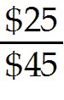 = .555555 or 55.56%
Diff: 1
Section: 16.6 Motivating Managers: The Agency Benefits of Leverage
Skill: Analytical

5) Assume that capital markets are perfect, you issue $25 million in new debt, and you issue $25 million in new equity. Your ownership stake in the firm following these new issues of debt and equity is closest to:
A) 50%
B) 55%
C) 58%
D) 33%
Answer: A
Explanation: A) Owner's equity = value - debt - new equity = 75 - 25 - 25 = $25 million
Total equity = owners equity + new equity = $25 + $25 = $50 million
Owner's stake = 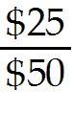 = .50 or 50.0%
Diff: 1
Section: 16.6 Motivating Managers: The Agency Benefits of Leverage
Skill: Analytical
6) Assume that capital markets are perfect except for the existence of corporate taxes. Your firm pays 40% of earnings in taxes and you decide to issue $25 million in new debt and $25 million in new equity. Your ownership stake in the firm following these new issues of debt and equity is closest to:
A) 58%
B) 55%
C) 33%
D) 50%
Answer: A
Explanation: A) VU = $75 million
VL = VU + τcD = $75 + .40($25) = $85 million

Owner's equity = value - debt - new equity = 85 - 25 - 25 = $35 million
Total equity = owners equity + new equity = $35 + $25 = $60 million
Owner's stake = 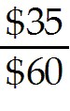 = .5833 or 58.33%
Diff: 2
Section: 16.6 Motivating Managers: The Agency Benefits of Leverage
Skill: Analytical

7) Assume that capital markets are perfect except for the existence of corporate taxes and that your firm pays 40% of earnings in taxes. If you want to maintain ownership of at least a 50%, then the minimum amount of debt that you must issue to fund the expansion is closest to:
A) $19 million
B) $18 million
C) $16 million
D) $20 million
Answer: B
Explanation: B) VU = $75 million
% Ownership = 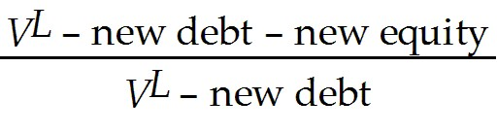
Given:
VL = VU + τcD
new equity = $50 million needed for expansion - the amount of new debt:

% Ownership = 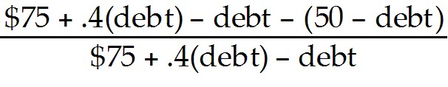
% Ownership = 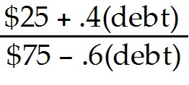 = .50 (given we want 50% ownership)
$25 + .4(debt) = .50($75 - .6(debt))
50 + 1.4(debt) = 75
Debt = 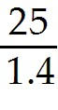 = $17.857 million
Diff: 3
Section: 16.6 Motivating Managers: The Agency Benefits of Leverage
Skill: Analytical
8) Assume that capital markets are perfect except for the existence of corporate taxes and that your firm pays 35% of earnings in taxes. If you want to maintain ownership of at least a 50%, then calculate the minimum amount of debt that you must issue to fund the expansion.
Answer: VU = $75 million
% Ownership =
Given:
VL = VU + τcD
New equity = $50 million needed for expansion - the amount of new debt:

% Ownership = 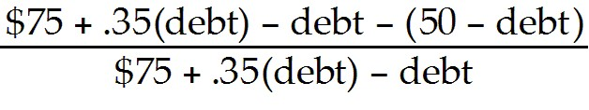
% Ownership = 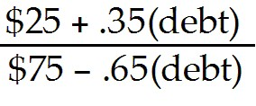 = .50 (given we want 50% ownership)
$25 + .35(debt) = .50($75 - .65(debt))
50 + 1.35(debt) = 75
Debt = 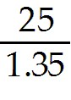 = $18.52 million
Diff: 3
Section: 16.6 Motivating Managers: The Agency Benefits of Leverage
Skill: Analytical

16.7 Agency Costs and the Trade-off Theory

Use the following information to answer the question(s) below.

If managed effectively, Rearden Metal will have assets with a market value of $200 million, $300 million, or $400 million next year, with each outcome being equally likely. Managers, however, may decided to engage in wasteful empire building, which will reduce Rearden's market value by $20 million in all cases. Managers may also increase the risk of the firm, changing the probability of each outcome to 50%, 5%, and 45% respectively.

1) What is the expected value of Rearden's assets if it were run efficiently?
A) $265 million
B) $280 million
C) $295 million
D) $300 million
Answer: D
Explanation: D) The expected value is just the weighted average of the possible outcomes.
E[assets] = 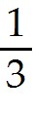($200) + ($300) + ($400) = $300 million
Diff: 1
Section: 16.7 Agency Costs and the Tradeoff Theory
Skill: Analytical
2) Suppose that the managers at Rearden Metal will engage in empire building unless that behavior increases the likelihood of bankruptcy. If Rearden has $180 million in debt due in one year, then the expected value of Rearden's assets is closest to:
A) $265 million
B) $280 million
C) $295 million
D) $300 million
Answer: B
Explanation: B) In all cases Rearden will be able to pay off its debt and avoid bankruptcy if it engages in empire building, even in the worse case they will have $200 million - $20 million = $180 million in assets.
The expected value is just the weighted average of the possible outcomes.
E[assets] = ($200 - $20) + ($300 - $20) + ($400 - $20) = $280 million
Diff: 2
Section: 16.7 Agency Costs and the Tradeoff Theory
Skill: Analytical

3) Suppose that the managers at Rearden Metal will engage in empire building unless that behavior increases the likelihood of bankruptcy. If Rearden has $190 million in debt due in one year, then the expected value of Rearden's assets is closest to:
A) $265 million
B) $280 million
C) $295 million
D) $300 million
Answer: D
Explanation: D) In this case the probability of bankruptcy is increased, since in the event of the worse outcome with empire building Rearden's assets would only be worth $200 - $20 = $180 million which will not cover the repayment of debt. Therefore the management team will not engage in empire building.
The expected value is just the weighted average of the possible outcomes.
E[assets] = ($200) + ($300) + ($400) = $300 million
Diff: 2
Section: 16.7 Agency Costs and the Tradeoff Theory
Skill: Analytical
4) Suppose that the managers at Rearden Metal will increase risk to maximize the expected payoff to equity holders. If Rearden has $180 million in debt due in one year, then the expected value of Rearden's assets is closest to:
A) $280 million
B) $295 million
C) $300 million
D) $900 million
Answer: C
Explanation: C) Expected Payoff to equity holders w/o increase in risk:
E[equity] = ($200 - $180) + ($300 - $180) + ($400 - $180) = $120 million
Expected Payoff to equity holders w/increase in risk:
E[equity] = (50%)($200 - $180) + (5%)($300 - $180) + (45%)($400 - $180) = $115 million

Therefore Rearden's managers will not increase the risk and the expected value of Rearden's assets is:
E[assets] = ($200) + ($300) + ($400) = $300 million
Diff: 3
Section: 16.7 Agency Costs and the Tradeoff Theory
Skill: Analytical

5) Suppose that the managers at Rearden Metal will increase risk to maximize the expected payoff to equity holders. If Rearden has $230 million in debt due in one year, then the expected value of Rearden's assets are closest to:
A) $280 million
B) $295 million
C) $300 million
D) $900 million
Answer: B
Explanation: B) Expected Payoff to equity holders w/o increase in risk:
E[equity] = ($200 - $200) + ($300 - $230) + ($400 - $230) = $70 million
Expected Payoff to equity holders w/increase in risk:
E[equity] = (50%)($200 - $200) + (5%)($300 - $230) + (45%)($400 - $230) = $80 million

Therefore Rearden's managers will increase the risk and the expected value of Rearden's assets is:
E[assets] = (50%)($200) + (5%)($300) + (45%)($400) = $295 million
Diff: 3
Section: 16.7 Agency Costs and the Tradeoff Theory
Skill: Analytical
6) Which of the following statements is FALSE?
A) The optimal level of debt D*, balances the costs and benefits of leverage.
B) As the debt level increases, the firm benefits from the interest tax shield (which has present value τ*D).
C) If the debt level is too large firm value is reduced due to the loss of tax benefits (when interest exceeds EBIT), financial distress costs, and the agency costs of leverage.
D) As the debt level increases, the firm faces worse incentives for management, which increase wasteful investment and perks.
Answer: D
Diff: 1
Section: 16.7 Agency Costs and the Tradeoff Theory
Skill: Conceptual

7) Which of the following statements is FALSE?
A) Firms with high R&D costs and future growth opportunities typically maintain high debt levels.
B) The tradeoff theory explains how firms should choose their capital structures to maximize value to current shareholders.
C) With tangible assets, the financial distress costs of leverage are likely to be low, as the assets can be liquidated for close to their full value.
D) Proponents of the management entrenchment theory of capital structure believe that managers choose a capital structure to avoid the discipline of debt and maintain their own job security.
Answer: A
Diff: 2
Section: 16.7 Agency Costs and the Tradeoff Theory
Skill: Conceptual

8) Which of the following firms is likely to maintain low levels of debt?
A) An electric utility
B) A tobacco company
C) An Internet firm
D) A mature restaurant chain
Answer: C
Diff: 1
Section: 16.7 Agency Costs and the Tradeoff Theory
Skill: Conceptual
Use the information for the question(s) below.

If it is managed efficiently, Luther industries will have assets with market value of $100 million, $300, million, or $500 million next year, with each outcome being equally likely. Managers may, however, engage in wasteful empire building which will reduce the firm's market value by $20 million in all cases. Managers may also increase the risk of the firm, changing the probability of each outcome to 50%, 20%, and 30% respectively.

9) If it is managed efficiently, then the expected market value of Luther's assets is closest to:
A) $300 million
B) $260
C) $240
D) $280 million
Answer: A
Explanation: A) Expected value = 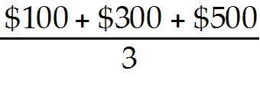 = $300 million
Diff: 1
Section: 16.7 Agency Costs and the Tradeoff Theory
Skill: Analytical

10) If its managers engage in empire building, then the expected market value of Luther's assets is closest to:
A) $260
B) $280 million
C) $240
D) $300 million
Answer: B
Explanation: B) Expected value = 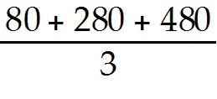 = $280 million
Diff: 1
Section: 16.7 Agency Costs and the Tradeoff Theory
Skill: Analytical

11) If its managers increase the risk of the firm, then the expected market value of Luther's assets is closest to:
A) $260
B) $240
C) $300 million
D) $280 million
Answer: A
Explanation: A) Expected value = .5(100) + .2(300) + .3(500) = $260 million
Diff: 1
Section: 16.7 Agency Costs and the Tradeoff Theory
Skill: Analytical
16.8 Asymmetric Information and Capital Structure

1) The idea that managers who perceive the firm's equity is under-priced will have a preference to fund investment using retained earnings, or debt, rather than equity is known as the:
A) signaling theory of debt.
B) lemons principle.
C) pecking order hypothesis.
D) credibility principle.
Answer: C
Diff: 1
Section: 16.8 Asymmetric Information and Capital Structure
Skill: Definition

2) The idea that claims in one's self-interest are credible only if they are supported by actions that would be too costly to take if the claims were untrue is known as the:
A) pecking order hypothesis.
B) credibility principle.
C) lemons principle.
D) signaling theory of debt.
Answer: B
Diff: 1
Section: 16.8 Asymmetric Information and Capital Structure
Skill: Definition

3) The idea that when a seller has private information about the value of good, buyers will discount the price they are willing to pay due to adverse selection is known as the:
A) pecking order hypothesis.
B) signaling theory of debt.
C) lemons principle.
D) credibility principle.
Answer: C
Diff: 1
Section: 16.8 Asymmetric Information and Capital Structure
Skill: Definition
Use the information for the question(s) below.

Electronic Gaming Incorporated (EGI) is a firm with no debt and its 20 million shares are currently trading for $16 per share. Based on the prospects for EGI's new hand held video game, management feels the true value of the firm is $20 per share. Management believes that the share price will reflect this higher value after the video game is released next fall. EGI has already announced plans to raise $100 million from investors to build a new factory.

4) Assume that EGI decides to raise the $100 million through the issuance of new shares prior to the release of the new video game. The number of new shares that EGI will issue is closest to:
A) 5.0 million
B) 6.25 million
C) 10 million
D) 1.6 million
Answer: B
Explanation: B) shares = 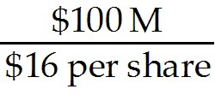 = 6,250,000 new shares
Diff: 1
Section: 16.8 Asymmetric Information and Capital Structure
Skill: Analytical

5) Assume that EGI decides to wait until after the release of the new video game before they raise the $100 million through the issuance of new shares. The number of new shares that EGI will issue is closest to:
A) 1.6 million
B) 5.0 million
C) 10 million
D) 6.25 million
Answer: B
Explanation: B) shares = 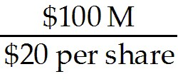 = 5,000,000 new shares
Diff: 1
Section: 16.8 Asymmetric Information and Capital Structure
Skill: Analytical
6) Assume that EGI decides to raise the $100 million through the issuance of new shares prior to the release of the new video game. EGI's share price following the release of the new video game will be closest to:
A) $18.00
B) $19.00
C) $20.00
D) $16.00
Answer: B
Explanation: B) shares = = 6,250,000 new shares

Total shares = 20M (existing) + 6.25M new = 26.25 million.

Total Value = existing value + $100M new factory
Total Value = $20 per share (true value) × 20 million shares + $100 = $500 million

Price per share = 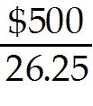 = $19.05
Diff: 2
Section: 16.8 Asymmetric Information and Capital Structure
Skill: Analytical

7) Assume that EGI decides to wait until after the release of the new video game before they raise the $100 million through the issuance of new shares. EGI's share price following the release of the new video game will be closest to:
A) $18.00
B) $20.00
C) $16.00
D) $19.00
Answer: B
Explanation: B) shares = = 5M new shares

Total shares = 20M (existing) + 5M new = 25 million.

Total value = existing value + $100M new factory
Total value = $20 per share (true value) × 20 million shares + $100 = $500 million

Price per share = 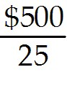 = $20.00
Diff: 2
Section: 16.8 Asymmetric Information and Capital Structure
Skill: Analytical
16.9 Capital Structure: The Bottom Line

1) Which of the following statements is FALSE?
A) The most important insight regarding capital structure goes back to Modigliani and Miller: With perfect capital markets, a firm's security choice alters the risk of the firm's equity, but it does not change its value or the amount it can raise from outside investors.
B) When agency costs are significant, short-term debt may be the most attractive form of external financing.
C) Too much debt can motivate managers and equity holders to take excessive risks or over-invest in a firm.
D) Of all the different possible imperfections that drive capital structure, the most clear-cut, and possibly the most significant, is taxes.
Answer: C
Diff: 1
Section: 16.9 Capital Structure: The Bottom Line
Skill: Conceptual

2) Which of the following influences a firm's choice of capital structure?
A) Taxes
B) Agency costs and benefits of leverage
C) Signaling and adverse selection
D) All of the above influence capital structure decisions.
Answer: D
Diff: 1
Section: 16.9 Capital Structure: The Bottom Line
Skill: Analytical

3) Which of the following is unlikely to influence a firm's choice of capital structure?
A) Taxes
B) Agency costs and benefits of leverage
C) Transaction costs
D) All of the above influence capital structure decisions.
Answer: C
Diff: 2
Section: 16.9 Capital Structure: The Bottom Line
Skill: Conceptual

